

**Letter of Intent**

**This is Letter of Intent alone is not a legally binding contract.** It is a proposal to Artist from ECU to provide services to ECU as described herein. If Artist agrees to the terms and conditions of this Letter of Intent, then Artist should sign both this Letter of Intent and the attached ECU Standard Addendum. If Artist is not agreeable to some or all of the terms or conditions set forth in this Letter of Intent, then Artist should contact ECU and discuss changes. If Artist and ECU subsequently reach mutual agreement on the terms all terms and conditions of a Letter of Intent, then Artist should sign and return the agreed upon Letter of Intent and the ECU Standard Addendum. Upon execution of the ECU Standard Addendum by an authorized ECU official, this Letter of Intent and the ECU Standard Addendum shall together form the contract between Artist and ECU.

If the parties never reach mutual agreement on the terms and conditions set forth in a Letter of Intent, then it and the ECU Standard Addendum shall be unenforceable and of no legal consequence.

**Full legal name of artist:**

**Mailing address:**

**Email:**

**Phone:**

**Artist website:**

**Artist fee:**

**Succinct statement of services to be provided at ECU:**

**Schedule and description of intended services on campus.**

**Event Date Time Location Audience size**

[] Y [] N The artist has a U.S. Tax identification Number or Social Security Number.

[] Y [] N Payment will be made to the artist named and at the address above.

[] Y [] N The artist agrees that the artist fee may be subject to Federal and/or NC tax withholding.

[] Y [] N The artist is currently employed by the state of North Carolina:

[] Y [] N The artist is in the country on a Visa. If yes, indicate type:

To receive payment, Artist must engage with ECU Materials Management, and complete all paperwork necessary to become eligible for payment under state and University policies and regulations. If Artist fails to complete all required paperwork and provide all requested information necessary to process payment no later than 60 calendar days after completion of the services, then ECU may deny payment.

**Authorized ECU official:**

(signature and date)

**Signature of artist and date:**

**Instructions to Artists/Payees:**

If Letter of Intent is agreeable, please sign the Letter of Intent and the ECU Standard Addendum.

Complete items 1, 3 and 9 on the Contractual Services Payment Request Form.



**ECU Standard Addendum**

This STANDARD ADDENDUM is a part of the agreement between NAME (full name of artist or entity to be paid, hereinafter called ARTIST) and East Carolina University (hereinafter referred to as PRESENTER) for an engagement on DATE.

1.  In consideration of the mutual promises of the parties set out in the Letter of Intent appended hereto and this ECU Standard Addendum, PRESENTER and ARTIST agree to the terms and conditions pursuant to which Artist shall make a VIRTUAL appearance and provide such other services as agreed to by the parties at East Carolina University, located in Greenville, North Carolina.

2.  PRESENTER will not make a deposit. To receive payment, Artist must engage with ECU Materials Management and complete all paperwork and provide all information required by Presenter in order to become eligible for payment under state and University policies and regulations. If Artist fails to complete all required paperwork and provide all requested information necessary to process payment no later than 60 calendar days after completion of the services, then ECU may deny payment.

North Carolina General Statutes 105‐163.1 and GS 105‐163.3 require income tax to be withheld at the rate of four percent (4%) from payments of more than $1,500.00 paid during a calendar year to nonresident individuals or nonresident entities for personal services performed in North Carolina in connection with a performance, an entertainment or athletic event, a speech, or the creation of a film, radio, or television program.

Exceptions include:

* North Carolina residents
* An individual who is an ordained or licensed member of the clergy
* Any entity that is exempt from North Carolina corporate income tax under N.C.G.S. 105‐130.11. The entity must provide verification of this tax exemption to the payer, such as a copy of the organization's federal determination letter of tax exemption or a copy of a letter of tax exemption from the Department of Revenue.
* A partnership that has a permanent place of business in North Carolina
* Corporations or limited liability companies that have obtained a Certificate of Authority from the North Carolina Secretary of State

Payment of the Artist Fee MINUS THE STATE WITHHOLDING TAX will be made by university check drawn upon an ECU account as PRESENTER in the following amount:

Artist Fee:  $

Less 4%  $

Adjusted Fee $

Notice: If the adjusted fee is made to a U.S. agent on behalf of a foreign artist, or paid directly to a foreign artist, ECU is required to withhold a thirty percent (30%) nonresident alien tax, unless said artist supplies support of a current and relevant tax treaty (Treas. Reg. Section 1.1441-1(b)(2)(ii)).

3. PAYMENT will be delivered to ARTIST at the address indicated on the Letter of Intent. Under no circumstances will the PRESENTER tender payment to the Artist(s) in the form of a cashier’s check or in cash, nor shall the PRESENTER be under any obligation to take any action to assist in cashing of payment.

4. ROYALTIES, UNION FEES, PAYMENT

Royalties, union fees, welfare, and insurance obligations, and other obligations--except as otherwise specifically noted in this Addendum--are a part of the ARTIST’s cost of production. PRESENTER shall not be responsible for the payment of these or other obligations.

5.  Any failure of ARTIST to perform may be excused only for proven detention because of sickness or injury, civil tumult or riot, epidemics, acts of God, or other conditions beyond the control of the Artist(s). ARTIST(S) must notify PRESENTER forthwith of any reason which might result in ARTIST(S’) failure to perform on the scheduled date(s).

6.  CANCELLATION BY ARTIST: In the event of cancellation caused by ARTIST(S’) unexcused inability to perform, PRESENTER reserves the right to cancel the entire contract and to be reimbursed by ARTIST(S) for any monies incurred in the advertising, promotion, purchase, reservation, and technical set-up of the facilities for the performance, and any other out-of-pocket expenses incurred by PRESENTER, as well as the right to enforce any other remedies allowed by law, and PRESENTER will be relieved of any responsibility under this Agreement in such event. ARTIST shall reimburse PRESENTER within thirty (30) calendar days of notification of cancellation to PRESENTER.

7.  TRAVEL MIX-UP RESPONSIBILITIES:  The agreed upon performance shall take place in Greenville, Pitt County, North Carolina. The ARTIST will be held responsible and subject to damages for all expenses caused PRESENTER for planning, promoting, and setting up for the performance(s) if the performance is delayed or prevented because the ARTIST travels to Greenville, SOUTH Carolina, instead of Greenville, NORTH CAROLINA OR if the ARTIST travels to the small community outside of Charlotte, North Carolina that is also called Greenville.  (The three-letter airport identification for Greenville, North Carolina, is PGV.)  ARTIST shall make any and all payments to Presenter required pursuant to this paragraph within thirty (30) calendar days of receipt of an invoice from Presenter.

8.  ACT OF GOD/FORCE DE MAJEURE:  Should the facility scheduled for this performance become unavailable or the obligations of PRESENTER under this Agreement become materially hampered, interrupted, or interfered with; or illegal, impossible, or so difficult or expensive as to be commercially impracticable; or by reason of any fire, casualty, lockout, strike, labor conditions, unavoidable accident, riot, war, act of terrorism, epidemic, pandemic, public health emergency, or act of God, including inclement weather that requires the closure of or limitation of services on the University campus; or by any other unforeseeable event beyond the parties' control; or by the enactment, issuance, or operation of any municipal, county, State, or federal law, ordinance or executive, administrative, governmental, or judicial regulation, order or decree; or by any local or national emergency, or similar occurrences beyond the control of PRESENTER, PRESENTER shall reserve the right to cancel this Agreement, whereupon the liability of PRESENTER to ARTIST shall be limited to out-of-pocket expenses incurred by ARTIST(S) prior to notice of cancellation by PRESENTER. Any such expenses of ARTIST must be supported by written, itemized, and paid invoices submitted by ARTIST or PRESENTER.  Should ARTIST fail to provide PRESENTER such documentation within thirty (30) calendar days of the notice of cancellation, PRESENTER shall have no obligation to reimburse ARTIST for his or her out-of-pocket expenses.

9.  ARTIST AGREES TO PROVIDE ALL EQUIPMENT AND SERVICES, EXCEPT AS OTHERWISE PROVIDED HEREIN. Any proposed rider or other designation by ARTIST of specific technical requirements to be met by PRESENTER including, but not limited to, specific equipment and facilities, electrical power, or technical services, must be provided to PRESENTER by ARTIST at least thirty days prior to the event and must be specifically agreed to in writing by PRESENTER and made a part of this Addendum. PRESENTER reserves the right to prevent the use of any equipment not specifically agreed to in writing and outlined in this addendum.

10.  HOTEL, GROUND TRANSPORATION: Unless outlined as a condition of this agreement, presenter does not provide local lodging and ground transportation.

11.  ARTIST shall not provide or give alcoholic beverages to ECU students and/or employees prior to, during, or after the performance(s). Should ARTIST provide or give alcoholic beverages to ECU students and/or employees prior to, during, or after the performance(s), it will constitute a material breach of this contract.

12.  The PRESENTER, as an Agency of the State of North Carolina, is not obligated to contribute to any union welfare fund and may in its discretion employ either union or nonunion labor. Adherence to union regulations by East Carolina University is only as a matter of courtesy and is not an obligation. In the event of the violation by PRESENTER of any union regulation or policies, PRESENTER shall be held harmless by ARTIST.

13.  ARTIST will be solely responsible for the content of material provided and shall hold PRESENTER harmless from any claim of libel, copyright infringement, or other alleged illegal use of materials performed by ARTIST at the performance(s) covered by this Agreement.

14.   East Carolina University, as a constituent institution of the University of North Carolina system, will be responsible for the conduct of its officers and employees arising out of the performance of this Agreement only to the extent set forth in the North Carolina Tort Claims Act, the Defense of State Employees Act, and/or the Excess Liability Policy administered through the North Carolina Department of Insurance, subject to the availability of appropriations and in proportion to and to the extent that such liability for damages is caused by or results from the acts or omissions of East Carolina University, its officers, or employees.

15.  The ARTIST hereby expressly agrees to indemnify and save harmless East Carolina University from claims, suits, actions, damages, and costs of every kind and description arising out of or resulting from ARTIST’S acts or omissions, whether negligent or intentional.

16.  All additions, deletions, and other amendments to this Addendum and any rider or list of specifications or requirements intended to be a part of the Addendum must be executed by all parties to this Addendum.

17.  If this Addendum is signed by someone other than ARTIST, the individual signing for the ARTIST expressly warrants that such individual is authorized by ARTIST to execute this Addendum for the ARTIST.

18.  This Agreement shall not be effective until executed by PRESENTER and ARTIST.  Any change in this Addendum made by ARTIST after the signature of PRESENTER shall constitute a counteroffer and shall not constitute a binding contract until any amendments or additions to the original Addendum have been approved and executed by the PRESENTER.

19.  It is expressly understood that this Addendum is not a joint venture of any nature of ARTIST and PRESENTER, nor do the provisions of this Addendum in any way establish ARTIST as the agent of PRESENTER. ARTIST, Artist(s’) employees, agents, or representatives shall not, in any manner, be construed to be the employees, agents, or representatives of the PRESENTER.

20.  LAWS OF THE STATE OF NORTH CAROLINA:  All performances governed by this Addendum shall be conducted in compliance with the laws of the State of North Carolina and the rules and applicable policies of East Carolina University. The validity, construction, and effect of this Addendum shall be governed by the laws of the State of North Carolina.

21.  Any contract between East Carolina University as PRESENTER and another party includes, by implication, the existing law of the State of North Carolina. PRESENTER, as a State agency, does not agree to binding arbitration, mediation, or any mandatory dispute resolution other than legal action in North Carolina courts.

22.  This standard ECU Standard Addendum is between ARTIST and East Carolina University, PRESENTER. The person signing for the University assumes no personal liability.

23.   This ECU Standard Addendum shall become a part of the contract between ARTIST and PRESENTER. In case of conflicts, inconsistencies, or incongruities, the ECU Standard Addendum shall and will prevail.

24.   Funds Availability--Any payments by PRESENTER under this Agreement that are due beyond the current fiscal year are conditioned on appropriation from the State of North Carolina of sufficient funds to cover the purposes set forth in this Agreement.

25.  Access to Records--The North Carolina State Auditor and Presenter’s internal auditors will be given access to persons and records that are generated as a result of, or are related to, this Agreement for purposes of verifying accounts and data affecting fees or performance in accordance with N.C.G.S. 147-64.7.

AGREED TO AND ACCEPTED:

**FOR ARTIST**

**by (name, please print)**

**signature and date**

EAST CAROLINA UNIVERSITY

By (name, please print)

Signature and date

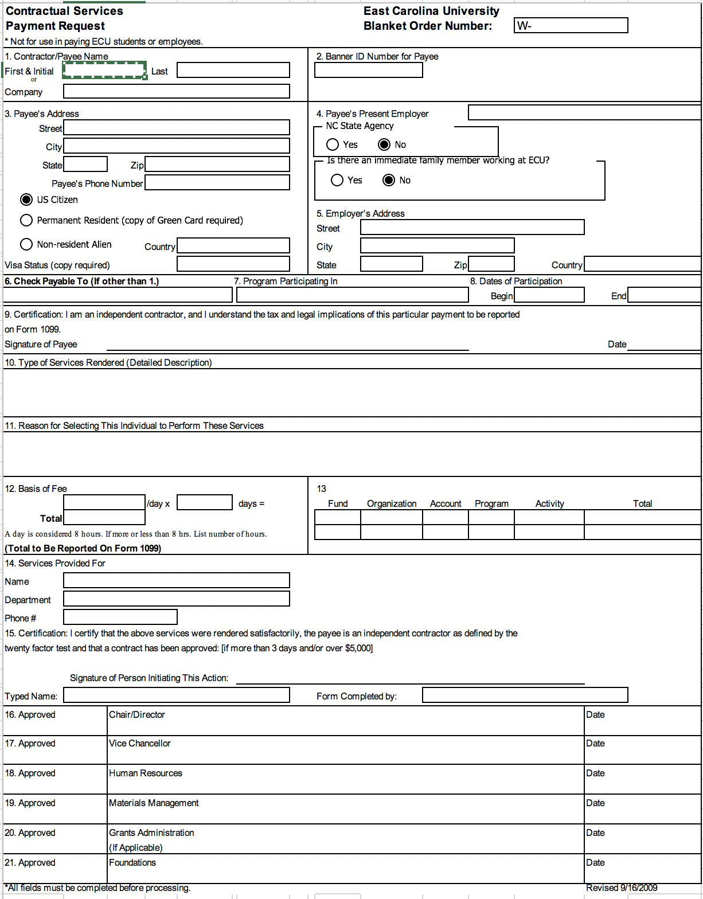

ARTIST: Complete fields 1, 3 and 9 only.

Notes to ECU Personnel:

Sequence of events: ECU signs only the Letter of Intent and sends Artist the signed LOI with the ECU Standard Addendum and CSPR attached. If artist is agreeable to the LOI, then Artist signs the LOI, the ECU Standard Addendum and the CSPR and returns them to ECU. ECU then signs the Standard Addendum and sends a signed copy to Artist. However, if ECU and Artist cannot initially agree on the language of the LOI, then they may try to reach an agreement. If ECU and Artist never agree on the language for the LOI, then Artist does not sign LOI and the process stops.

This Letter of Intent and ECU Standard Addendum cannot be used to pay individuals currently employed by ECU.

To receive payment, Artist must engage with ECU Materials Management and complete all necessary paperwork to become eligible for payment under state and University policies and regulations. Please assist Artists to make the appropriate contacts within Materials Management. If Artist fails to complete all required paperwork no later than 60 calendar days after completion of the services, then ECU may deny payment.

In most cases, travel expenses should be included as a part of the Artist’s fee.

Remember the six-week rule: It takes about six weeks to process paperwork resulting in payment.